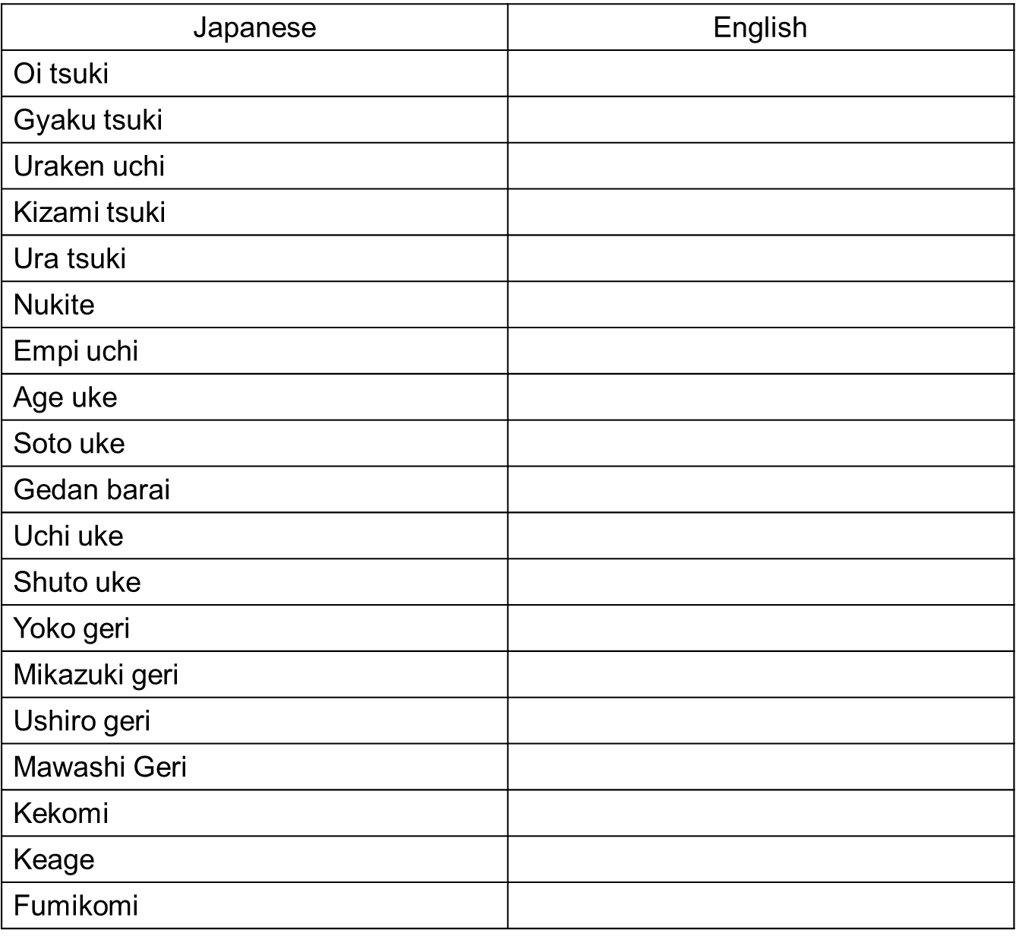

Name:________________________

1. Black Belt Candidate – Japanese to English theory test. Please Use a black ink pen

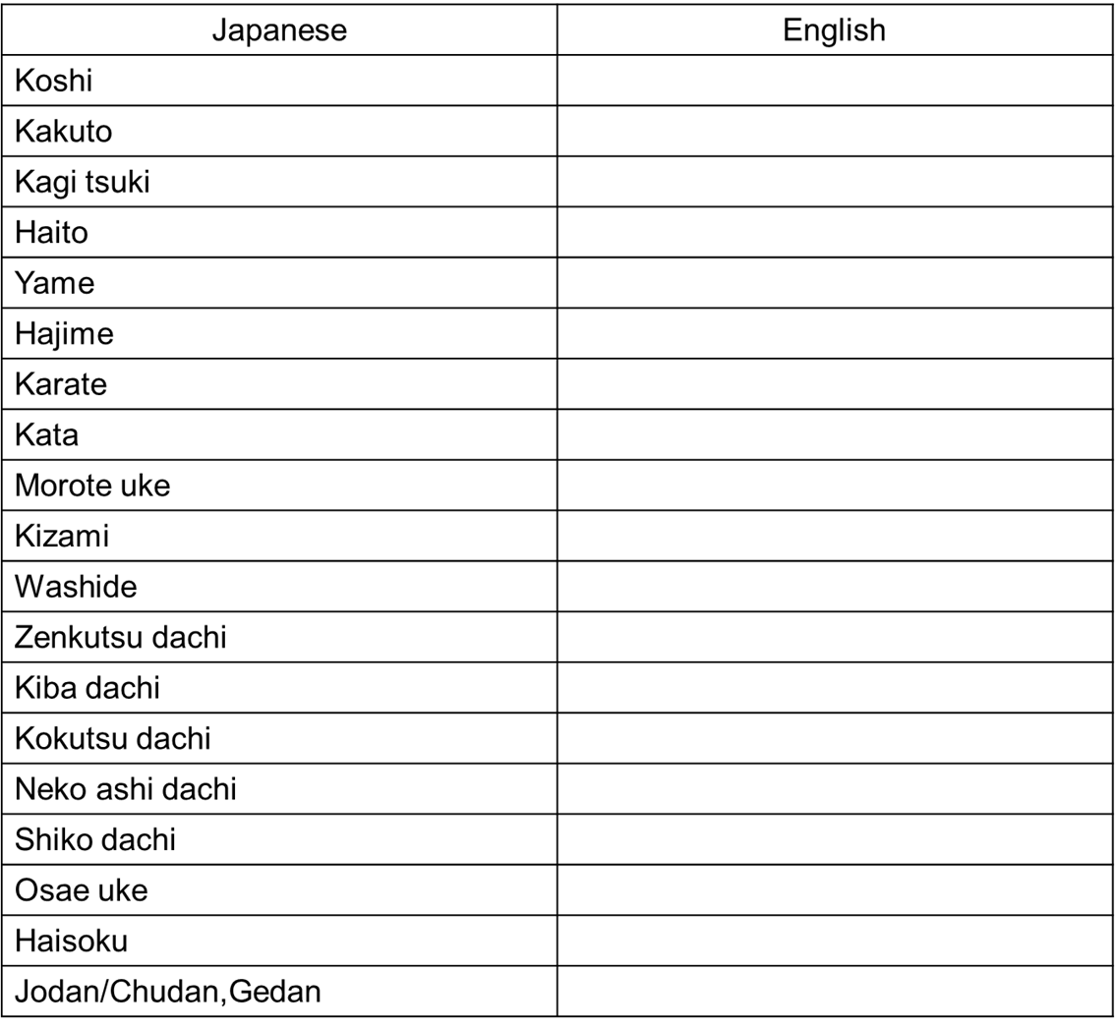

Name:________________________

1. Black Belt Candidate – Japanese to English theory test. Please Use a black ink pen

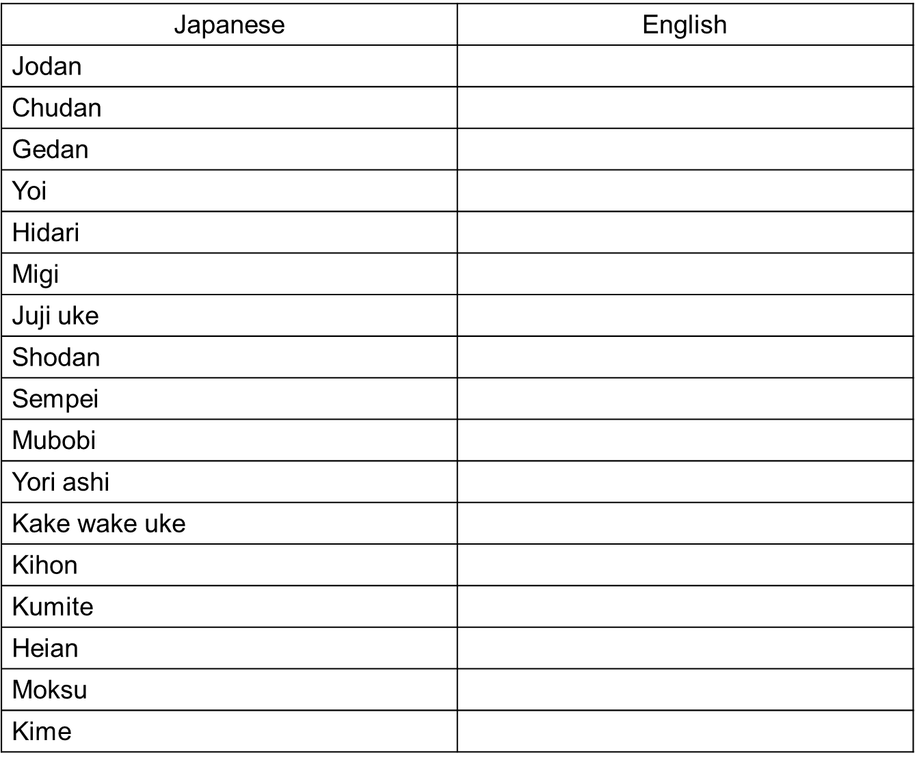

Name:________________________

1. Black Belt Candidate – Japanese to English theory test. Please Use a black ink pen